Обучающийся Чекалкин Семён Александрович
Факультет прикладной информатики Группа К3242
Направление подготовки 09.03.03 Прикладная информатика
Образовательная программа Мобильные и сетевые технологии 2026
Преподаватель Говорова Марина Михайловна
Министерство науки и высшего образования Российской Федерации
ФЕДЕРАЛЬНОЕ ГОСУДАРСТВЕННОЕ АВТОНОМНОЕ
ОБРАЗОВАТЕЛЬНОЕ УЧРЕЖДЕНИЕ ВЫСШЕГО ОБРАЗОВАНИЯ
НАЦИОНАЛЬНЫЙ ИССЛЕДОВАТЕЛЬСКИЙ УНИВЕРСИТЕТ
ИТМО

Санкт-Петербург
2026

ОТЧЕТ
ПО ЛАБОРАТОРНОЙ РАБОТЕ № 3.2
«Создание таблиц базы данных PostgreSQL. Заполнение таблиц рабочими данными»
по дисциплине «Проектирование и реализация баз данных»

Цель работы: овладеть практическими навыками создания таблиц базы данных PostgreSQL 1Х, заполнения их рабочими данными, резервного копирования и восстановления БД.
Практическое задание:
- Создать базу данных с использованием pgAdmin 4 (согласно индивидуальному заданию).
- Создать схему в составе базы данных.
- Создать таблицы базы данных.
- Установить ограничения на данные: Primary Key, Unique, Check, Foreign Key.
- Заполнить таблицы БД рабочими данными.
- Создать резервную копию БД.
Указание:
Создать две резервные копии:
- с расширением CUSTOM для восстановления БД;
- с расширением для листинга (в отчете);
- при создании резервных копий БД настроить параметры Dump options для Type of objects и Queries .
- Восстановить БД.

Выполнение:
Наименование БД: Автомастерская
Вариант: 11
Схема инфологической модели БД ЛР 2 (IDEF1X):
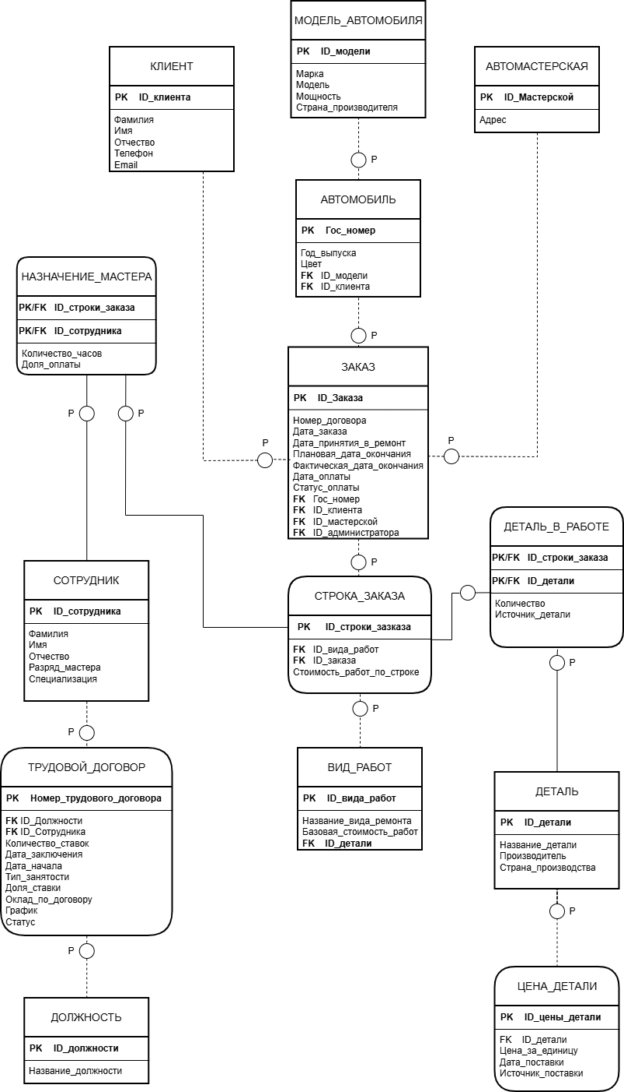
Схема логической модели базы данных, сгенерированная в Generate ERD:
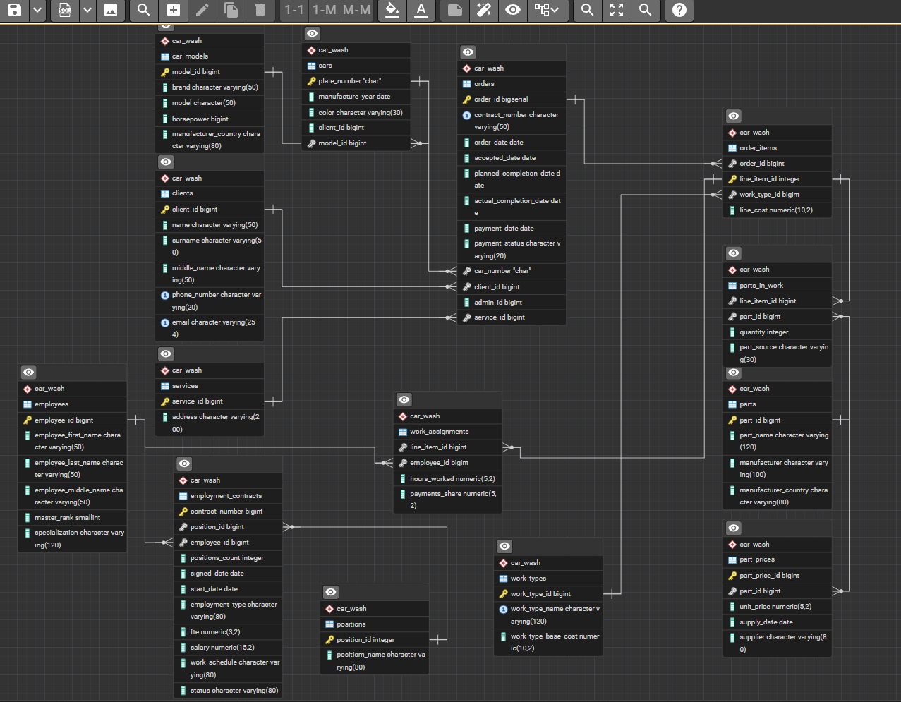
Содержимое файла dump_plain:
--
-- PostgreSQL database dump
--

\restrict GBpHIUB7YKyjN4RAvmf8iT5hkLTuX0ONQfb1lPcY278sL2bX613SDVbRcT04WXe

-- Dumped from database version 17.9
-- Dumped by pg_dump version 17.9

-- Started on 2026-03-31 15:10:45

SET statement_timeout = 0;
SET lock_timeout = 0;
SET idle_in_transaction_session_timeout = 0;
SET transaction_timeout = 0;
SET client_encoding = 'UTF8';
SET standard_conforming_strings = on;
SELECT pg_catalog.set_config('search_path', '', false);
SET check_function_bodies = false;
SET xmloption = content;
SET client_min_messages = warning;
SET row_security = off;

--
-- TOC entry 6 (class 2615 OID 16388)
-- Name: car_wash; Type: SCHEMA; Schema: -; Owner: postgres
--

CREATE SCHEMA car_wash;

ALTER SCHEMA car_wash OWNER TO postgres;

SET default_tablespace = '';

SET default_table_access_method = heap;

--
-- TOC entry 221 (class 1259 OID 16474)
-- Name: car_models; Type: TABLE; Schema: car_wash; Owner: postgres
--

CREATE TABLE car_wash.car_models (
model_id bigint NOT NULL,
brand character varying(50) NOT NULL,
model character(50) NOT NULL,
horsepower bigint,
manufacturer_country character varying(80),
CONSTRAINT "horsepoweк_check" CHECK (((horsepower > 0) AND (horsepower <= 2000)))
);

ALTER TABLE car_wash.car_models OWNER TO postgres;

--
-- TOC entry 222 (class 1259 OID 16479)
-- Name: cars; Type: TABLE; Schema: car_wash; Owner: postgres
--

CREATE TABLE car_wash.cars (
plate_number "char" NOT NULL,
manufacture_year date,
color character varying(30),
client_id bigint NOT NULL,
model_id bigint NOT NULL
);

ALTER TABLE car_wash.cars OWNER TO postgres;

--
-- TOC entry 220 (class 1259 OID 16469)
-- Name: clients; Type: TABLE; Schema: car_wash; Owner: postgres
--

CREATE TABLE car_wash.clients (
client_id bigint NOT NULL,
name character varying(50) NOT NULL,
surname character varying(50),
middle_name character varying(50) NOT NULL,
phone_number character varying(20) NOT NULL,
email character varying(254),
CONSTRAINT clients_check CHECK (((name)::text ~ '^[А-ЯЁ][а-яё]*$'::text)),
CONSTRAINT email_check CHECK (((email)::text ~ '^[A-Za-z0-9._%+-]+@[A-Za-z0-9.-]+\.[A-Za-z]{2,}$'::text)),
CONSTRAINT middle_name_check CHECK (((middle_name)::text ~ '^[А-ЯЁ][а-яё]*$'::text)),
CONSTRAINT name_check CHECK (((name)::text ~ '^[А-ЯЁ][а-яё]*$'::text)),
CONSTRAINT phone_number_check CHECK (((phone_number)::text ~ '^(\+7|8)[0-9]{10}$'::text)),
CONSTRAINT surname_check CHECK (((surname)::text ~ '^[А-ЯЁ][а-яё]*$'::text))
);

ALTER TABLE car_wash.clients OWNER TO postgres;

--
-- TOC entry 226 (class 1259 OID 16499)
-- Name: employees; Type: TABLE; Schema: car_wash; Owner: postgres
--

CREATE TABLE car_wash.employees (
employee_id bigint NOT NULL,
employee_first_name character varying(50) NOT NULL,
employee_last_name character varying(50) NOT NULL,
employee_middle_name character varying(50),
master_rank smallint NOT NULL,
specialization character varying(120) NOT NULL
);

ALTER TABLE car_wash.employees OWNER TO postgres;

--
-- TOC entry 228 (class 1259 OID 16509)
-- Name: employment_contracts; Type: TABLE; Schema: car_wash; Owner: postgres
--

CREATE TABLE car_wash.employment_contracts (
contract_number bigint NOT NULL,
position_id bigint NOT NULL,
employee_id bigint NOT NULL,
positions_count integer NOT NULL,
signed_date date NOT NULL,
start_date date NOT NULL,
employment_type character varying(80) NOT NULL,
fte numeric(3,2) NOT NULL,
salary numeric(15,2),
work_schedule character varying(80),
status character varying(80)
);

ALTER TABLE car_wash.employment_contracts OWNER TO postgres;

--
-- TOC entry 224 (class 1259 OID 16489)
-- Name: order_items; Type: TABLE; Schema: car_wash; Owner: postgres
--

CREATE TABLE car_wash.order_items (
order_id bigint NOT NULL,
line_item_id integer NOT NULL,
work_type_id bigint NOT NULL,
line_cost numeric(10,2) NOT NULL
);

ALTER TABLE car_wash.order_items OWNER TO postgres;

--
-- TOC entry 219 (class 1259 OID 16390)
-- Name: orders; Type: TABLE; Schema: car_wash; Owner: postgres
--

CREATE TABLE car_wash.orders (
order_id bigint NOT NULL,
contract_number character varying(50) NOT NULL,
order_date date NOT NULL,
accepted_date date NOT NULL,
planned_completion_date date NOT NULL,
actual_completion_date date NOT NULL,
payment_date date NOT NULL,
payment_status character varying(20) NOT NULL,
car_number "char" NOT NULL,
client_id bigint NOT NULL,
admin_id bigint,
service_id bigint
);

ALTER TABLE car_wash.orders OWNER TO postgres;

--
-- TOC entry 218 (class 1259 OID 16389)
-- Name: orders_order_id_seq; Type: SEQUENCE; Schema: car_wash; Owner: postgres
--

CREATE SEQUENCE car_wash.orders_order_id_seq
START WITH 1
INCREMENT BY 1
NO MINVALUE
NO MAXVALUE
CACHE 1;

ALTER SEQUENCE car_wash.orders_order_id_seq OWNER TO postgres;

--
-- TOC entry 5022 (class 0 OID 0)
-- Dependencies: 218
-- Name: orders_order_id_seq; Type: SEQUENCE OWNED BY; Schema: car_wash; Owner: postgres
--

ALTER SEQUENCE car_wash.orders_order_id_seq OWNED BY car_wash.orders.order_id;

--
-- TOC entry 232 (class 1259 OID 16525)
-- Name: part_prices; Type: TABLE; Schema: car_wash; Owner: postgres
--

CREATE TABLE car_wash.part_prices (
part_price_id bigint NOT NULL,
part_id bigint NOT NULL,
unit_price numeric(5,2) NOT NULL,
supply_date date NOT NULL,
supplier character varying(80) NOT NULL
);

ALTER TABLE car_wash.part_prices OWNER TO postgres;

--
-- TOC entry 230 (class 1259 OID 16517)
-- Name: parts; Type: TABLE; Schema: car_wash; Owner: postgres
--

CREATE TABLE car_wash.parts (
part_id bigint NOT NULL,
part_name character varying(120) NOT NULL,
manufacturer character varying(100),
manufacturer_country character varying(80)
);

ALTER TABLE car_wash.parts OWNER TO postgres;

--
-- TOC entry 231 (class 1259 OID 16522)
-- Name: parts_in_work; Type: TABLE; Schema: car_wash; Owner: postgres
--

CREATE TABLE car_wash.parts_in_work (
line_item_id bigint NOT NULL,
part_id bigint NOT NULL,
quantity integer NOT NULL,
part_source character varying(30)
);

ALTER TABLE car_wash.parts_in_work OWNER TO postgres;

--
-- TOC entry 227 (class 1259 OID 16504)
-- Name: positions; Type: TABLE; Schema: car_wash; Owner: postgres
--

CREATE TABLE car_wash.positions (
position_id integer NOT NULL,
positiom_name character varying(80) NOT NULL
);

ALTER TABLE car_wash.positions OWNER TO postgres;

--
-- TOC entry 223 (class 1259 OID 16484)
-- Name: services; Type: TABLE; Schema: car_wash; Owner: postgres
--

CREATE TABLE car_wash.services (
service_id bigint NOT NULL,
address character varying(200) NOT NULL,
CONSTRAINT address_chk CHECK (((address)::text ~ '^[А-ЯЁа-яё0-9\s\.,\-\(\)\/]+$'::text))
);

ALTER TABLE car_wash.services OWNER TO postgres;

--
-- TOC entry 229 (class 1259 OID 16514)
-- Name: work_assignments; Type: TABLE; Schema: car_wash; Owner: postgres
--

CREATE TABLE car_wash.work_assignments (
line_item_id bigint NOT NULL,
employee_id bigint NOT NULL,
hours_worked numeric(5,2),
payments_share numeric(5,2) NOT NULL
);

ALTER TABLE car_wash.work_assignments OWNER TO postgres;

--
-- TOC entry 225 (class 1259 OID 16494)
-- Name: work_types; Type: TABLE; Schema: car_wash; Owner: postgres
--

CREATE TABLE car_wash.work_types (
work_type_id bigint NOT NULL,
work_type_name character varying(120) NOT NULL,
work_type_base_cost numeric(10,2) NOT NULL
);

ALTER TABLE car_wash.work_types OWNER TO postgres;

--
-- TOC entry 4795 (class 2604 OID 16393)
-- Name: orders order_id; Type: DEFAULT; Schema: car_wash; Owner: postgres
--

ALTER TABLE ONLY car_wash.orders ALTER COLUMN order_id SET DEFAULT nextval('car_wash.orders_order_id_seq'::regclass);

--
-- TOC entry 5005 (class 0 OID 16474)
-- Dependencies: 221
-- Data for Name: car_models; Type: TABLE DATA; Schema: car_wash; Owner: postgres
--

COPY car_wash.car_models (model_id, brand, model, horsepower, manufacturer_country) FROM stdin;
1 Toyota Camry 181 Япония
2 BMW X5 250 Германия
3 Audi A6 190 Германия
4 Kia Sportage 150 Южная Корея
5 Lada Vesta 106 Россия
\.

--
-- TOC entry 5006 (class 0 OID 16479)
-- Dependencies: 222
-- Data for Name: cars; Type: TABLE DATA; Schema: car_wash; Owner: postgres
--

COPY car_wash.cars (plate_number, manufacture_year, color, client_id, model_id) FROM stdin;
\.

--
-- TOC entry 5004 (class 0 OID 16469)
-- Dependencies: 220
-- Data for Name: clients; Type: TABLE DATA; Schema: car_wash; Owner: postgres
--

COPY car_wash.clients (client_id, name, surname, middle_name, phone_number, email) FROM stdin;
1 Иван Петров Алексеевич +79161234567 ivan.petrov@mail.ru
2 Алексей Сидоров Игоревич 89161234568 alex.sidorov@gmail.com
3 Мария Иванова Сергеевна +79031234569 maria.ivanova@mail.ru
4 Дмитрий Кузнецов Владимирович 89001234567 d.kuznetsov@yandex.ru
5 Анна Смирнова Дмитриевна +79876543210 anna.smirnova@mail.ru
\.

--
-- TOC entry 5010 (class 0 OID 16499)
-- Dependencies: 226
-- Data for Name: employees; Type: TABLE DATA; Schema: car_wash; Owner: postgres
--

COPY car_wash.employees (employee_id, employee_first_name, employee_last_name, employee_middle_name, master_rank, specialization) FROM stdin;
1 Павел Орлов Иванович 3 Детейлинг
2 Сергей Морозов Алексеевич 2 Мойка кузова
3 Андрей Фёдоров Петрович 4 Полировка
4 Никита Волков Сергеевич 1 Уборка салона
5 Игорь Попов Владимирович 5 Администрирование
\.

--
-- TOC entry 5012 (class 0 OID 16509)
-- Dependencies: 228
-- Data for Name: employment_contracts; Type: TABLE DATA; Schema: car_wash; Owner: postgres
--

COPY car_wash.employment_contracts (contract_number, position_id, employee_id, positions_count, signed_date, start_date, employment_type, fte, salary, work_schedule, status) FROM stdin;
1001 2 1 1 2024-01-01 2024-01-10 Full-time 1.00 60000.00 2/2 Active
1002 2 2 1 2024-01-02 2024-01-11 Full-time 1.00 55000.00 5/2 Active
1003 3 3 1 2024-01-03 2024-01-12 Part-time 0.50 30000.00 3/3 Active
1004 4 4 1 2024-01-04 2024-01-13 Full-time 1.00 45000.00 5/2 Active
1005 1 5 1 2024-01-05 2024-01-14 Full-time 1.00 70000.00 5/2 Active
\.

--
-- TOC entry 5008 (class 0 OID 16489)
-- Dependencies: 224
-- Data for Name: order_items; Type: TABLE DATA; Schema: car_wash; Owner: postgres
--

COPY car_wash.order_items (order_id, line_item_id, work_type_id, line_cost) FROM stdin;
\.

--
-- TOC entry 5003 (class 0 OID 16390)
-- Dependencies: 219
-- Data for Name: orders; Type: TABLE DATA; Schema: car_wash; Owner: postgres
--

COPY car_wash.orders (order_id, contract_number, order_date, accepted_date, planned_completion_date, actual_completion_date, payment_date, payment_status, car_number, client_id, admin_id, service_id) FROM stdin;
\.

--
-- TOC entry 5016 (class 0 OID 16525)
-- Dependencies: 232
-- Data for Name: part_prices; Type: TABLE DATA; Schema: car_wash; Owner: postgres
--

COPY car_wash.part_prices (part_price_id, part_id, unit_price, supply_date, supplier) FROM stdin;
\.

--
-- TOC entry 5014 (class 0 OID 16517)
-- Dependencies: 230
-- Data for Name: parts; Type: TABLE DATA; Schema: car_wash; Owner: postgres
--

COPY car_wash.parts (part_id, part_name, manufacturer, manufacturer_country) FROM stdin;
1 Микрофибра CleanPro Германия
2 Шампунь авто AutoCare Россия
3 Полироль ShineMax Италия
4 Фильтр салона FilterTech Польша
5 Щетка BrushMaster Китай
\.

--
-- TOC entry 5015 (class 0 OID 16522)
-- Dependencies: 231
-- Data for Name: parts_in_work; Type: TABLE DATA; Schema: car_wash; Owner: postgres
--

COPY car_wash.parts_in_work (line_item_id, part_id, quantity, part_source) FROM stdin;
\.

--
-- TOC entry 5011 (class 0 OID 16504)
-- Dependencies: 227
-- Data for Name: positions; Type: TABLE DATA; Schema: car_wash; Owner: postgres
--

COPY car_wash.positions (position_id, positiom_name) FROM stdin;
1 Администратор
2 Мастер
3 Уборщик
4 Кассир
5 Старший мастер
\.

--
-- TOC entry 5007 (class 0 OID 16484)
-- Dependencies: 223
-- Data for Name: services; Type: TABLE DATA; Schema: car_wash; Owner: postgres
--

COPY car_wash.services (service_id, address) FROM stdin;
1 Москва, ул. Ленина, 10
2 Санкт-Петербург, Невский пр., 25
3 Казань, ул. Баумана, 5
4 Екатеринбург, ул. Мира, 12
5 Новосибирск, ул. Советская, 8
\.

--
-- TOC entry 5013 (class 0 OID 16514)
-- Dependencies: 229
-- Data for Name: work_assignments; Type: TABLE DATA; Schema: car_wash; Owner: postgres
--

COPY car_wash.work_assignments (line_item_id, employee_id, hours_worked, payments_share) FROM stdin;
\.

--
-- TOC entry 5009 (class 0 OID 16494)
-- Dependencies: 225
-- Data for Name: work_types; Type: TABLE DATA; Schema: car_wash; Owner: postgres
--

COPY car_wash.work_types (work_type_id, work_type_name, work_type_base_cost) FROM stdin;
1 Мойка кузова 500.00
2 Химчистка салона 2000.00
3 Полировка 3000.00
4 Чернение шин 400.00
5 Детейлинг 5000.00
\.

--
-- TOC entry 5023 (class 0 OID 0)
-- Dependencies: 218
-- Name: orders_order_id_seq; Type: SEQUENCE SET; Schema: car_wash; Owner: postgres
--

SELECT pg_catalog.setval('car_wash.orders_order_id_seq', 1, false);

--
-- TOC entry 4820 (class 2606 OID 16478)
-- Name: car_models car_models_pkey; Type: CONSTRAINT; Schema: car_wash; Owner: postgres
--

ALTER TABLE ONLY car_wash.car_models
ADD CONSTRAINT car_models_pkey PRIMARY KEY (model_id);

--
-- TOC entry 4822 (class 2606 OID 16483)
-- Name: cars cars_pkey; Type: CONSTRAINT; Schema: car_wash; Owner: postgres
--

ALTER TABLE ONLY car_wash.cars
ADD CONSTRAINT cars_pkey PRIMARY KEY (plate_number);

--
-- TOC entry 4816 (class 2606 OID 16542)
-- Name: clients client_id_unique; Type: CONSTRAINT; Schema: car_wash; Owner: postgres
--

ALTER TABLE ONLY car_wash.clients
ADD CONSTRAINT client_id_unique UNIQUE (client_id, email, phone_number);

--
-- TOC entry 4818 (class 2606 OID 16544)
-- Name: clients clients_pkey; Type: CONSTRAINT; Schema: car_wash; Owner: postgres
--

ALTER TABLE ONLY car_wash.clients
ADD CONSTRAINT clients_pkey PRIMARY KEY (client_id);

--
-- TOC entry 4834 (class 2606 OID 16503)
-- Name: employees employees_pkey; Type: CONSTRAINT; Schema: car_wash; Owner: postgres
--

ALTER TABLE ONLY car_wash.employees
ADD CONSTRAINT employees_pkey PRIMARY KEY (employee_id);

--
-- TOC entry 4838 (class 2606 OID 16513)
-- Name: employment_contracts employment_contracts_pkey; Type: CONSTRAINT; Schema: car_wash; Owner: postgres
--

ALTER TABLE ONLY car_wash.employment_contracts
ADD CONSTRAINT employment_contracts_pkey PRIMARY KEY (contract_number);

--
-- TOC entry 4806 (class 2606 OID 16539)
-- Name: car_models manufacturer_country_check; Type: CHECK CONSTRAINT; Schema: car_wash; Owner: postgres
--

ALTER TABLE car_wash.car_models
ADD CONSTRAINT manufacturer_country_check CHECK (((manufacturer_country)::text ~ '^[A-Za-zА-ЯЁа-яё\s\-]+$'::text)) NOT VALID;

--
-- TOC entry 4809 (class 2606 OID 16582)
-- Name: order_items order_items_line_cost_check; Type: CHECK CONSTRAINT; Schema: car_wash; Owner: postgres
--

ALTER TABLE car_wash.order_items
ADD CONSTRAINT order_items_line_cost_check CHECK ((line_cost >= (0)::numeric)) NOT VALID;

--
-- TOC entry 4826 (class 2606 OID 16581)
-- Name: order_items order_items_line_item_id_key; Type: CONSTRAINT; Schema: car_wash; Owner: postgres
--

ALTER TABLE ONLY car_wash.order_items
ADD CONSTRAINT order_items_line_item_id_key UNIQUE (line_item_id);

--
-- TOC entry 4828 (class 2606 OID 16493)
-- Name: order_items order_items_pkey; Type: CONSTRAINT; Schema: car_wash; Owner: postgres
--

ALTER TABLE ONLY car_wash.order_items
ADD CONSTRAINT order_items_pkey PRIMARY KEY (line_item_id);

--
-- TOC entry 4796 (class 2606 OID 16577)
-- Name: orders orders_check; Type: CHECK CONSTRAINT; Schema: car_wash; Owner: postgres
--

ALTER TABLE car_wash.orders
ADD CONSTRAINT orders_check CHECK ((accepted_date >= order_date)) NOT VALID;

--
-- TOC entry 4797 (class 2606 OID 16578)
-- Name: orders orders_check1; Type: CHECK CONSTRAINT; Schema: car_wash; Owner: postgres
--

ALTER TABLE car_wash.orders
ADD CONSTRAINT orders_check1 CHECK ((planned_completion_date >= accepted_date)) NOT VALID;

--
-- TOC entry 4798 (class 2606 OID 16579)
-- Name: orders orders_check2; Type: CHECK CONSTRAINT; Schema: car_wash; Owner: postgres
--

ALTER TABLE car_wash.orders
ADD CONSTRAINT orders_check2 CHECK ((actual_completion_date >= accepted_date)) NOT VALID;

--
-- TOC entry 4812 (class 2606 OID 16395)
-- Name: orders orders_pkey; Type: CONSTRAINT; Schema: car_wash; Owner: postgres
--

ALTER TABLE ONLY car_wash.orders
ADD CONSTRAINT orders_pkey PRIMARY KEY (order_id);

--
-- TOC entry 4814 (class 2606 OID 16556)
-- Name: orders orders_unique; Type: CONSTRAINT; Schema: car_wash; Owner: postgres
--

ALTER TABLE ONLY car_wash.orders
ADD CONSTRAINT orders_unique UNIQUE (order_id, contract_number);

--
-- TOC entry 4842 (class 2606 OID 16529)
-- Name: part_prices part_prices_pkey; Type: CONSTRAINT; Schema: car_wash; Owner: postgres
--

ALTER TABLE ONLY car_wash.part_prices
ADD CONSTRAINT part_prices_pkey PRIMARY KEY (part_price_id);

--
-- TOC entry 4840 (class 2606 OID 16521)
-- Name: parts parts_pkey; Type: CONSTRAINT; Schema: car_wash; Owner: postgres
--

ALTER TABLE ONLY car_wash.parts
ADD CONSTRAINT parts_pkey PRIMARY KEY (part_id);

--
-- TOC entry 4807 (class 2606 OID 16540)
-- Name: cars plate_check; Type: CHECK CONSTRAINT; Schema: car_wash; Owner: postgres
--

ALTER TABLE car_wash.cars
ADD CONSTRAINT plate_check CHECK (((plate_number)::text ~ '^[АВЕКМНОРСТУХ]\d{3}[АВЕКМНОРСТУХ]{2}\d{2,3}$'::text)) NOT VALID;

--
-- TOC entry 4836 (class 2606 OID 16508)
-- Name: positions positions_pkey; Type: CONSTRAINT; Schema: car_wash; Owner: postgres
--

ALTER TABLE ONLY car_wash.positions
ADD CONSTRAINT positions_pkey PRIMARY KEY (position_id);

--
-- TOC entry 4824 (class 2606 OID 16488)
-- Name: services services_pkey; Type: CONSTRAINT; Schema: car_wash; Owner: postgres
--

ALTER TABLE ONLY car_wash.services
ADD CONSTRAINT services_pkey PRIMARY KEY (service_id);

--
-- TOC entry 4830 (class 2606 OID 16498)
-- Name: work_types work_types_pkey; Type: CONSTRAINT; Schema: car_wash; Owner: postgres
--

ALTER TABLE ONLY car_wash.work_types
ADD CONSTRAINT work_types_pkey PRIMARY KEY (work_type_id);

--
-- TOC entry 4810 (class 2606 OID 16595)
-- Name: work_types work_types_work_type_base_cost_check; Type: CHECK CONSTRAINT; Schema: car_wash; Owner: postgres
--

ALTER TABLE car_wash.work_types
ADD CONSTRAINT work_types_work_type_base_cost_check CHECK ((work_type_base_cost >= (0)::numeric)) NOT VALID;

--
-- TOC entry 4832 (class 2606 OID 16594)
-- Name: work_types work_types_work_type_name_key; Type: CONSTRAINT; Schema: car_wash; Owner: postgres
--

ALTER TABLE ONLY car_wash.work_types
ADD CONSTRAINT work_types_work_type_name_key UNIQUE (work_type_name);

--
-- TOC entry 4846 (class 2606 OID 16545)
-- Name: cars cars_client_id_fkey; Type: FK CONSTRAINT; Schema: car_wash; Owner: postgres
--

ALTER TABLE ONLY car_wash.cars
ADD CONSTRAINT cars_client_id_fkey FOREIGN KEY (client_id) REFERENCES car_wash.clients(client_id) NOT VALID;

--
-- TOC entry 4847 (class 2606 OID 16550)
-- Name: cars cars_model_id_fkey; Type: FK CONSTRAINT; Schema: car_wash; Owner: postgres
--

ALTER TABLE ONLY car_wash.cars
ADD CONSTRAINT cars_model_id_fkey FOREIGN KEY (model_id) REFERENCES car_wash.car_models(model_id) NOT VALID;

--
-- TOC entry 4850 (class 2606 OID 16611)
-- Name: employment_contracts employment_contracts_employee_id_fkey; Type: FK CONSTRAINT; Schema: car_wash; Owner: postgres
--

ALTER TABLE ONLY car_wash.employment_contracts
ADD CONSTRAINT employment_contracts_employee_id_fkey FOREIGN KEY (employee_id) REFERENCES car_wash.employees(employee_id) NOT VALID;

--
-- TOC entry 4851 (class 2606 OID 16606)
-- Name: employment_contracts employment_contracts_position_id_fkey; Type: FK CONSTRAINT; Schema: car_wash; Owner: postgres
--

ALTER TABLE ONLY car_wash.employment_contracts
ADD CONSTRAINT employment_contracts_position_id_fkey FOREIGN KEY (position_id) REFERENCES car_wash.positions(position_id) NOT VALID;

--
-- TOC entry 4848 (class 2606 OID 16583)
-- Name: order_items order_items_order_id_fkey; Type: FK CONSTRAINT; Schema: car_wash; Owner: postgres
--

ALTER TABLE ONLY car_wash.order_items
ADD CONSTRAINT order_items_order_id_fkey FOREIGN KEY (order_id) REFERENCES car_wash.orders(order_id) NOT VALID;

--
-- TOC entry 4849 (class 2606 OID 16588)
-- Name: order_items order_items_work_type_id_fkey; Type: FK CONSTRAINT; Schema: car_wash; Owner: postgres
--

ALTER TABLE ONLY car_wash.order_items
ADD CONSTRAINT order_items_work_type_id_fkey FOREIGN KEY (work_type_id) REFERENCES car_wash.work_types(work_type_id) NOT VALID;

--
-- TOC entry 4843 (class 2606 OID 16572)
-- Name: orders orders_car_number_fkey; Type: FK CONSTRAINT; Schema: car_wash; Owner: postgres
--

ALTER TABLE ONLY car_wash.orders
ADD CONSTRAINT orders_car_number_fkey FOREIGN KEY (car_number) REFERENCES car_wash.cars(plate_number) NOT VALID;

--
-- TOC entry 4844 (class 2606 OID 16562)
-- Name: orders orders_client_id_fkey; Type: FK CONSTRAINT; Schema: car_wash; Owner: postgres
--

ALTER TABLE ONLY car_wash.orders
ADD CONSTRAINT orders_client_id_fkey FOREIGN KEY (client_id) REFERENCES car_wash.clients(client_id) NOT VALID;

--
-- TOC entry 4845 (class 2606 OID 16557)
-- Name: orders orders_service_id_fkey; Type: FK CONSTRAINT; Schema: car_wash; Owner: postgres
--

ALTER TABLE ONLY car_wash.orders
ADD CONSTRAINT orders_service_id_fkey FOREIGN KEY (service_id) REFERENCES car_wash.services(service_id) NOT VALID;

--
-- TOC entry 4856 (class 2606 OID 16626)
-- Name: part_prices part_prices_part_id_fkey; Type: FK CONSTRAINT; Schema: car_wash; Owner: postgres
--

ALTER TABLE ONLY car_wash.part_prices
ADD CONSTRAINT part_prices_part_id_fkey FOREIGN KEY (part_id) REFERENCES car_wash.parts(part_id) NOT VALID;

--
-- TOC entry 4854 (class 2606 OID 16616)
-- Name: parts_in_work parts_in_work_line_item_id_fkey; Type: FK CONSTRAINT; Schema: car_wash; Owner: postgres
--

ALTER TABLE ONLY car_wash.parts_in_work
ADD CONSTRAINT parts_in_work_line_item_id_fkey FOREIGN KEY (line_item_id) REFERENCES car_wash.order_items(line_item_id) NOT VALID;

--
-- TOC entry 4855 (class 2606 OID 16621)
-- Name: parts_in_work parts_in_work_part_id_fkey; Type: FK CONSTRAINT; Schema: car_wash; Owner: postgres
--

ALTER TABLE ONLY car_wash.parts_in_work
ADD CONSTRAINT parts_in_work_part_id_fkey FOREIGN KEY (part_id) REFERENCES car_wash.parts(part_id) NOT VALID;

--
-- TOC entry 4852 (class 2606 OID 16601)
-- Name: work_assignments work_assignments_employee_id_fkey; Type: FK CONSTRAINT; Schema: car_wash; Owner: postgres
--

ALTER TABLE ONLY car_wash.work_assignments
ADD CONSTRAINT work_assignments_employee_id_fkey FOREIGN KEY (employee_id) REFERENCES car_wash.employees(employee_id) NOT VALID;

--
-- TOC entry 4853 (class 2606 OID 16596)
-- Name: work_assignments work_assignments_line_item_id_fkey; Type: FK CONSTRAINT; Schema: car_wash; Owner: postgres
--

ALTER TABLE ONLY car_wash.work_assignments
ADD CONSTRAINT work_assignments_line_item_id_fkey FOREIGN KEY (line_item_id) REFERENCES car_wash.order_items(line_item_id) NOT VALID;

-- Completed on 2026-03-31 15:10:45

--
-- PostgreSQL database dump complete
--

\unrestrict GBpHIUB7YKyjN4RAvmf8iT5hkLTuX0ONQfb1lPcY278sL2bX613SDVbRcT04WXe

